**Healthcare**

An important application is the use of cloud technologies to support doctors in providing more effective diagnostic processes. In particular, here we discuss electrocardiogram (ECG) data analysis on the cloud.

ECG is the electrical manifestation of the contractile activity of the heart’s myocardium. This activity produces a specific waveform that is repeated over time and that represents the heartbeat. The analysis of the shape of the ECG waveform is used to identify arrhythmias and is the most common way to detect heart disease.

Even though remote ECG monitoring does not necessarily require cloud technologies, cloud computing introduces opportunities that would be otherwise hardly achievable. The first advantage is the elasticity of the cloud infrastructure that can grow and shrink according to the requests served.

The second advantage is ubiquity. (existing or being everywhere at the same time)

Finally, cost savings constitute another reason for the use of cloud technology in healthcare

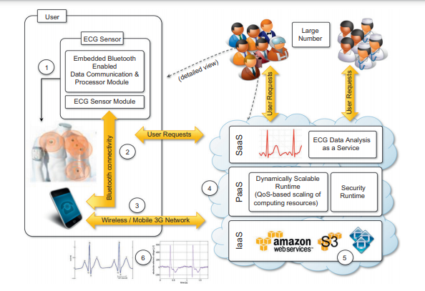

**Geoscience: satellite image processing**

Geoscience applications collect, produce, and analyze massive amounts of geospatial and nonspatial data. . In particular, the geographic information system (GIS) is a major element of geoscience applications. GIS applications capture, store, manipulate, analyze, manage, and present all types of geographically referenced data.

